About Program Notes

Programs for performances can disperse valuable and interesting information. They also make terrific souvenirs for the cast.

We require that you include the following:

- The Missoula Children’s Theatre authorship credits for key creative personnel and copyright information found on the next page.

We encourage you to include the following at your discretion, should room permit:

- The included show synopsis and MCT company overview.

- All foundation and/or arts organization graphics included.

- Any local sponsoring organization logo or information.

- Complete list of cast members, assistant directors, accompanist, lighting technician, school staff and anyone else who helped to make your week a success.

Along with the following statements:

- There should be no flash photography during the performance. There will be a time for photos immediately following the show.

- Please observe the following video courtesies: keep the aisles clear and stay in one place while recording.

- Please silence all cell phones.

  Celebrating over 50 years of touring, the Missoula Children’s Theatre International Tour has fostered developmental life skills in more than a million kids. Our tour reaches 65,000 children in more than 1,000 communities in all 50 states and 15+ countries each year. One of the many ways the Missoula Children’s Theatre remains vibrant is through generous donors all over the world. If you would like to support MCT, visit MCTinc.org/give or text “MCTGive” to 44321.    “Guess what? I made it…I’m in the play!”  On stage or behind the scenes, your child is a STAR! We invite you to honor their experience with a “star” in the MCT Galaxy, located in MCT headquarters in Missoula, MT! To see a sample of a star and learn more about this unique way to celebrate your child and support MCT, visit MCTinc.org/get-involved/mct-galaxy-wall. Stars are only $50 and can be customized with a name, the memory you wish to commemorate, date and location.    Missoula Children’s Theatre  200 N. Adams, Missoula, MT 59802-4718  MCTinc.org 406-728-1911 tour@MCTinc.org  CHARACTERS  Younger Beauty Lou  Older Beauty Lou  Slim  Dusty  Fleabite Clyde  Imaginary Friend  Beast  Younger Daughters  Older Daughters  Country Folk  Barnyard Critters  Assistant Directors  Accompanist  Buck –Tour Actor/Director  Director – MCT Tour Actor Director |  |  | 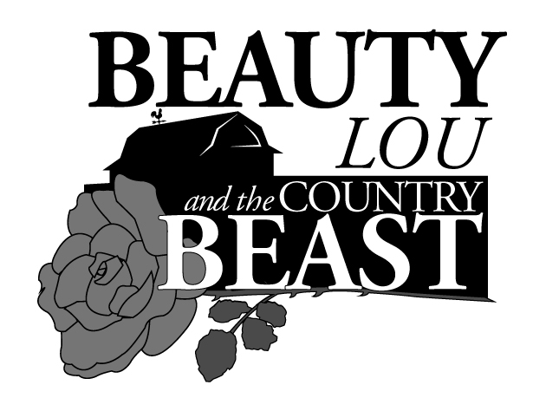  Adapted by  JIM CARON  Music and Lyrics by  MICHAEL MCGILL and JIM CARON  Additional Music by  JON HART and MICHAEL SCHOONER  Copyright © 2011 MCT, Inc.  MISSOULA CHILDREN’S THEATRE (MCT, INC)  200 North Adams Missoula, Montana 59802-4718  Phone 406-728-1911 Fax 406-721-0637  MCTinc.org  All Rights Reserved  BEAUTY LOU AND THE COUNTRY BEAST SYNOPSIS  Missoula Children’s Theatre presents BEAUTY LOU AND THE COUNTRY BEAST, an original country western adaptation of the classic fairy tale BEAUTY AND THE BEAST. Beauty Lou is the oldest daughter of the bronc-bustin’ balladeer Buck. At the local county fair, young Beauty Lou is upset by the ungrateful behavior of a miner who has won the blue ribbon for his beautiful roses. She calls him a beast and wishes that he would look like one too. Years later, when in danger of losing the family farm, Buck meets the miner-turned-beast. Beauty Lou agrees to befriend the Beast to save her family. Beauty Lou and the Beast both learn to look beyond appearances and first impressions and to see the beauty that dwells inside. The story, set in the American West, also features Beauty Lou’s six sisters, her Imaginary Friend, her dog Fleabite Clyde, farmhands Slim and Dusty, the neighborly Country Folk and the Barnyard Critters.  TOUR SPONSORS    01

