About Program Notes

Programs for performances can disperse valuable and interesting information. They also make terrific souvenirs for the cast.

We require that you include the following:

- The Missoula Children’s Theatre authorship credits for key creative personnel and copyright information found on the next page.

We encourage you to include the following at your discretion, should room permit:

- The included show synopsis and MCT company overview.

- All foundation and/or arts organization graphics included.

- Any local sponsoring organization logo or information.

- Complete list of cast members, assistant directors, accompanist, lighting technician, school staff and anyone else who helped to make your week a success.

Along with the following statements:

- There should be no flash photography during the performance. There will be a time for photos immediately following the show.

- Please observe the following video courtesies: keep the aisles clear and stay in one place while recording.

- Please silence all cell phones.

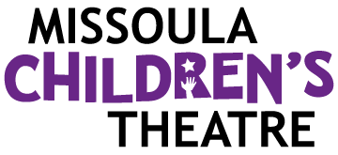  Celebrating over 50 years of touring, the Missoula Children’s Theatre International Tour has fostered developmental life skills in more than a million kids. Our tour reaches 65,000 children in more than 1,000 communities in all 50 states and 15+ countries each year. One of the many ways the Missoula Children’s Theatre remains vibrant is through generous donors all over the world. If you would like to support MCT, visit MCTinc.org/give or text “MCTGive” to 44321.  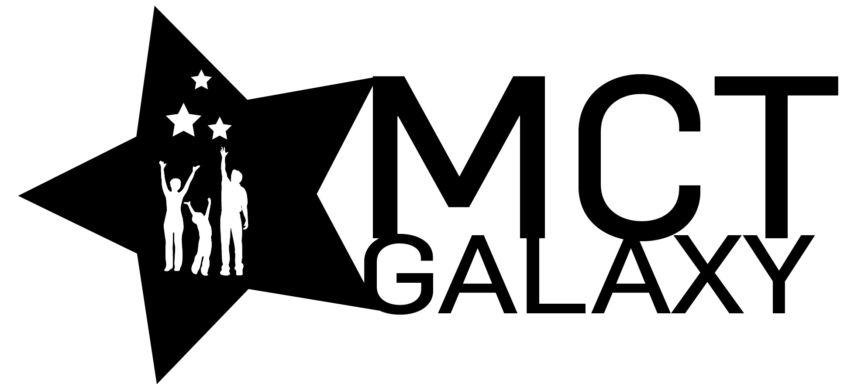  “Guess what? I made it…I’m in the play!”  On stage or behind the scenes, your child is a STAR! We invite you to honor their experience with a “star” in the MCT Galaxy, located in MCT headquarters in Missoula, MT! To see a sample of a star and learn more about this unique way to celebrate your child and support MCT, visit MCTinc.org/get-involved/mct-galaxy-wall. Stars are only $50 and can be customized with a name, the memory you wish to commemorate, date and location.    Missoula Children’s Theatre  200 N. Adams, Missoula, MT 59802-4718  MCTinc.org 406-728-1911 tour@MCTinc.org |  | 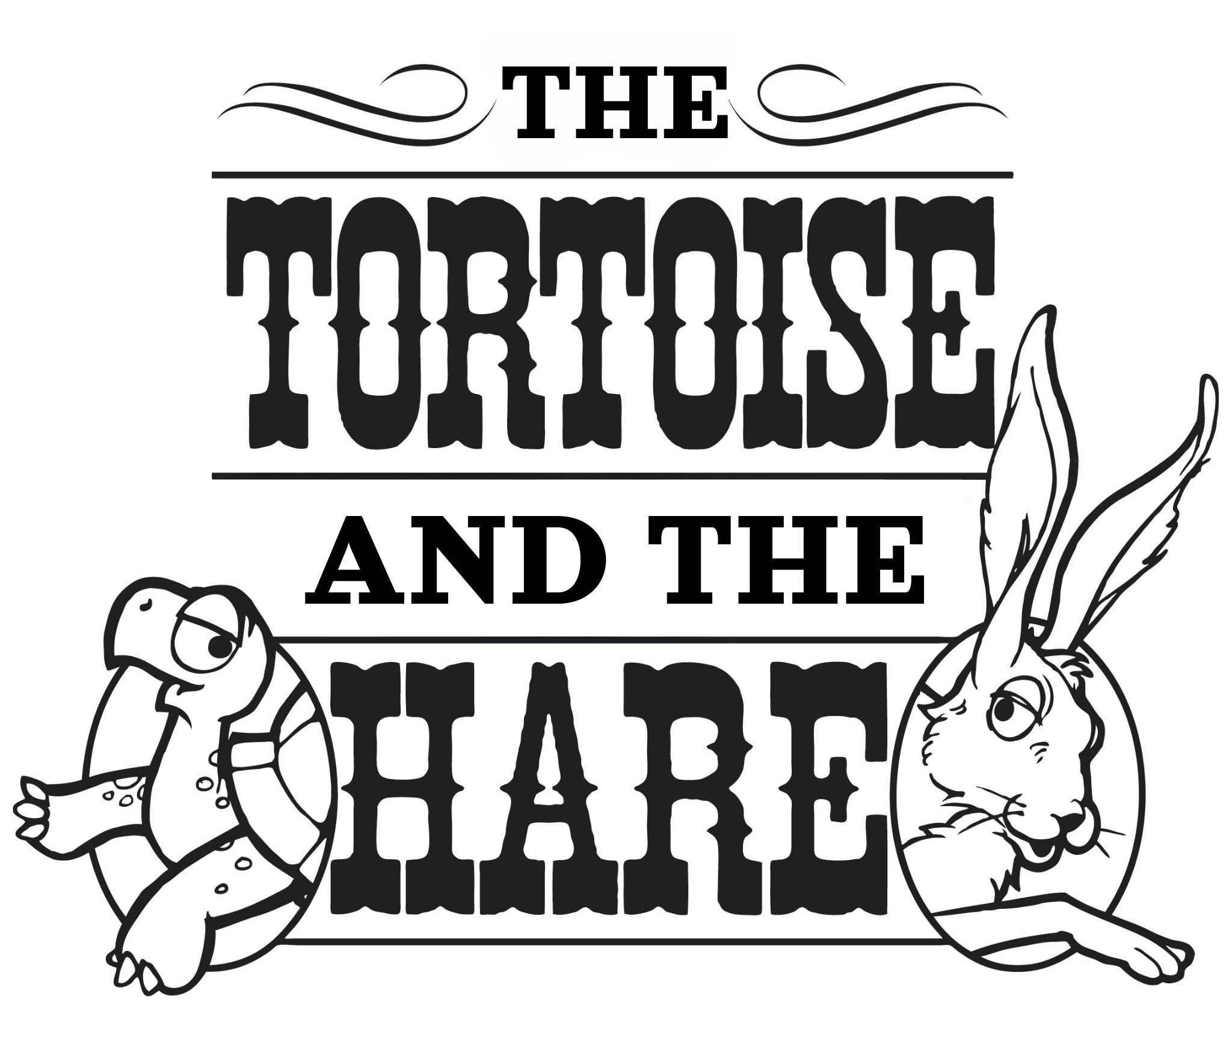  Adapted by  Emily Morrison  Music by  Gregory Boris  Lyrics by  Gregory Boris and Emily Morrison  Copyright © 2025 MCT, Inc.  MISSOULA CHILDREN’S THEATRE (MCT, INC)  200 North Adams Missoula, Montana 59802-4718  Phone 406-728-1911 Fax 406-721-0637  MCTinc.org  All Rights Reserved
CAST OF CHARACTERS  Curly Hare  Taylor Tortoise  Ginger Hare  Tobias Tortoise  Harry Armadillo  Professor Pumpernickel  Professor Persimmon  Scooter the Gecko  Giuseppe Iguana  Oggy Froggy  Flamingos (Rosie, Coral, Shrimpy)  Gators (Blossom, Poppy, Petunia)  Peter Puma  Deedee Diamondback  Tourists  Astronauts  Manatees  Mission Commander Mittens  Moon Manx  Assistant Directors  Accompanist  Jean Goodall–Tour Actor/Director  Director–Tour Actor/Director |  | THE TORTOISE AND THE HARE SYNOPSIS  The Missoula Children’s Theatre’s twist on Aesop’s classic is a hare-raising, ab-shell-lute whirlwind of fun! Taylor Tortoise and Curly Hare’s competitive antics are getting out of control, and all the other animals in their little town outside of Cape Canaveral, Florida, get roped into the shenanigans. When a group of astronauts comes through town, Curly Hare comes up with their kookiest stunt ever – to be the first animals on the moon! Well, talking animals, anyway. Taylor Tortoise and Curly Hare race to build a rocket and beat the other to space, but will their rivalry drive away their friends in the process? Who will make it to the moon first? And once they get to the moon…then what? The Tortoise and the Hare learn that maybe winning ISN’T everything; they can accomplish so much more by working together!  TOUR SPONSORS  

