About Program Notes

Programs for performances can disperse valuable and interesting information. They also make terrific souvenirs for the cast.

We require that you include the following:

- The Missoula Children’s Theatre authorship credits for key creative personnel and copyright information found on the next page.

We encourage you to include the following at your discretion, should room permit:

- The included show synopsis and MCT company overview.

- All foundation and/or arts organization graphics included.

- Any local sponsoring organization logo or information.

- Complete list of cast members, assistant directors, accompanist, lighting technician, school staff and anyone else who helped to make your week a success.

Along with the following statements:

- There should be no flash photography during the performance. There will be a time for photos immediately following the show.

- Please observe the following video courtesies: keep the aisles clear and stay in one place while recording.

- Please silence all cell phones.

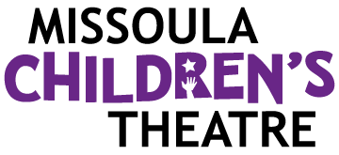  Celebrating over 50 years of touring, the Missoula Children’s Theatre International Tour has fostered developmental life skills in more than a million kids. Our tour reaches 65,000 children in more than 1,000 communities in all 50 states and 15+ countries each year. One of the many ways the Missoula Children’s Theatre remains vibrant is through generous donors all over the world. If you would like to support MCT, visit MCTinc.org/give or text “MCTGive” to 44321.    “Guess what? I made it…I’m in the play!”  On stage or behind the scenes, your child is a STAR! We invite you to honor their experience with a “star” in the MCT Galaxy, located in MCT headquarters in Missoula, MT! To see a sample of a star and learn more about this unique way to celebrate your child and support MCT, visit MCTinc.org/get-involved/mct-galaxy-wall. Stars are only $50 and can be customized with a name, the memory you wish to commemorate, date and location.    Missoula Children’s Theatre  200 N. Adams, Missoula, MT 59802-4718  MCTinc.org 406-728-1911 tour@MCTinc.org |  |  |  | 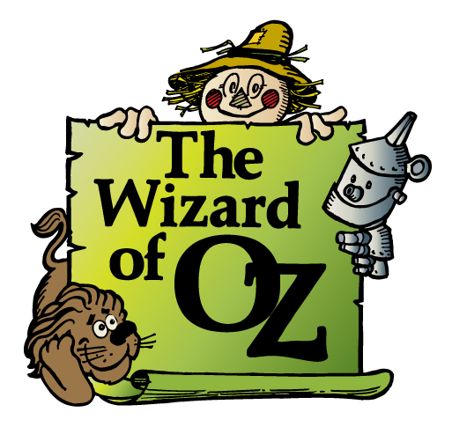  Adapted by  JIM CARON  Additional Dialogue by  MICHELLE NIGH  Music and Lyrics by  MICHAEL MCGILL, BOB HUBLEY and DAVID SIMMONS  Copyright © 2011 MCT, Inc.  MISSOULA CHILDREN’S THEATRE (MCT, INC)  200 North Adams Missoula, Montana 59802-4718  Phone 406-728-1911 Fax 406-721-0637  www.MCTinc.org  All Rights Reserved
Cast of Characters:  Dorothy  Tin Man  Lion  Toto  The Professor/Wizard  The Green Guard  Wicked Witch  Glinda  Mayor Munchkin  Farmer Munchkin  Illusionists  Munchkins  Kalidahs  Sprouts  Assistant Directors  Aunt Em (or Uncle Henry) / Scarecrow–MCT Tour Actor/Director  Director–Tour Actor/Director |  |  |  | THE WIZARD OF OZ SYNOPSIS  The story is as familiar as it is beloved. That nasty tornado carries Dorothy and her canine pal Toto from the friendly confines of her Kansas home to a fabled fantasy of mystery in the land of Oz. Our story begins with the Illusionists who set the scene for the tale you are about to witness. With the help of the Munchkins and Glinda herself, the young Miss Gale and her loyal pooch join forces with the Scarecrow, the Tin Man and, of course, the Cowardly Lion. Off they go down the Yellow Brick Road–side-stepping a Wicked Witch and her ferocious Kalidahs, Sprouts that are far nicer-looking than they act, and the loyal Green Guard–on their perilous journey to find the Wizard and ask for his help. For they are sure his Wizness will grant their wishes and send Dorothy and Toto back to their home–or will he? We’ll never tell. Come see for yourself.  TOUR SPONSORS  

