ABOUT PROGRAM NOTES

Programs for performances can disperse valuable and interesting information. They also make terrific souvenirs for the cast.

We require that you include the following:

- The Missoula Children’s Theatre authorship credits for key creative personnel and copyright information found on the next page.

We encourage you to include the following at your discretion, should room permit:

- The included show synopsis and MCT company overview.

- All foundation and/or arts organization graphics included.

- Any local sponsoring organization logo or information.

- Complete list of cast members, assistant directors, accompanist, lighting technician, school staff and anyone else who helped to make your week a success.

Along with the following statements:

- There should be no flash photography during the performance. There will be a time for photos immediately following the show.

- Please observe the following video courtesies: keep the aisles clear and stay in one place while recording.

- Please silence all cell phones.

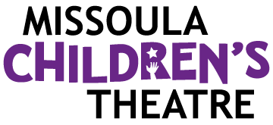  Celebrating over 50 years of touring, the Missoula Children’s Theatre International Tour has fostered developmental life skills in more than a million kids. Our tour reaches 65,000 children in more than 1,000 communities in all 50 states and 15+ countries each year. One of the many ways the Missoula Children’s Theatre remains vibrant is through generous donors all over the world. If you would like to support MCT, visit MCTinc.org/give or text “MCTGive” to 44321.    “Guess what? I made it…I’m in the play!”  On stage or behind the scenes, your child is a STAR! We invite you to honor their experience with a “star” in the MCT Galaxy, located in MCT headquarters in Missoula, MT! To see a sample of a star and learn more about this unique way to celebrate your child and support MCT, visit MCTinc.org/get-involved/mct-galaxy-wall. Stars are only $50 and can be customized with a name, the memory you wish to commemorate, date and location.    Missoula Children’s Theatre  200 N. Adams, Missoula, MT 59802-4718  MCTinc.org 406-728-1911 tour@MCTinc.org |  | 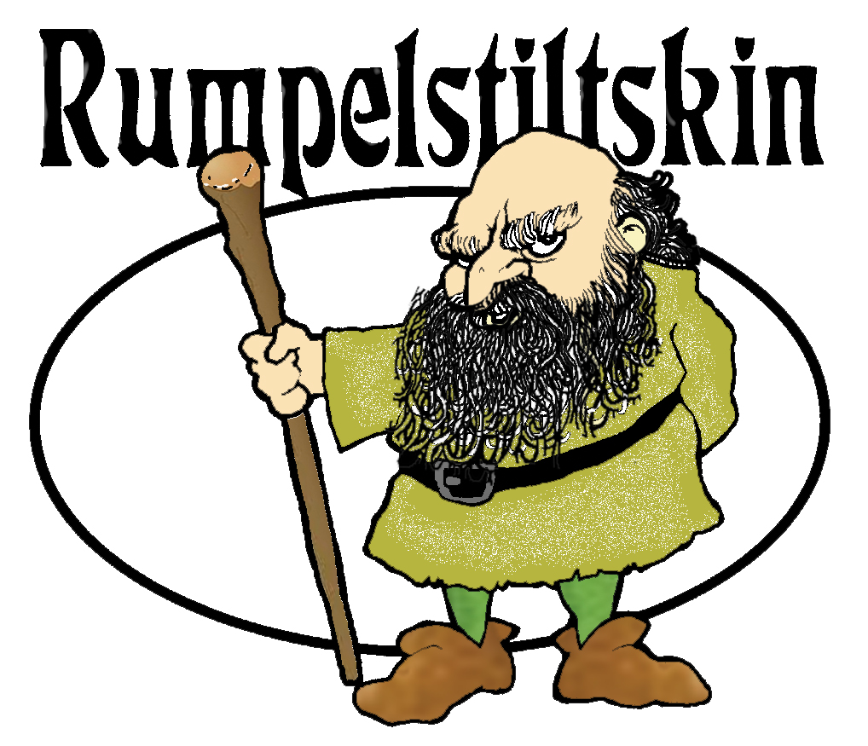  Adapted by  DON KUKLA  Music by  MICHAEL MCGILL  Additional Music by  DON KUKLA  Arranged by  MICHAEL MCGILL  Copyright © 1993, 2003, 2006 Don Kukla, Michael McGill & MCT, Inc  MISSOULA CHILDREN’S THEATRE (MCT, INC)  200 North Adams Missoula, Montana 59802-4718  Phone 406-728-1911 Fax 406-721-0637  www.MCTinc.org  All Rights Reserved
CAST OF CHARACTERS  Rumpelstiltskin  Young Clara  Older Clara  King Whatsat  Queen Beatrice  Jester  Wizards  Gnomes  Knights  Villagers  Busy Bees  Assistant Directors  Accompanist  Royal Musician – Tour Actor/Director  Director – Tour Actor/Director |  | RUMPELSTILTSKIN SYNOPSIS  A strange little gnome appears from here, there and everywhere. He will spin your straw into gold...for a price. If his price is too steep, you must guess his name...RUMPELSTILTSKIN! Join in the fun of Festival Time and help Clara guess the mischievous little gnome's name. You will also encounter a Jester, Villagers, Wizards, a Queen, a King, Knights and a band of busy little Bees. This heart-warming tale of mischief and friendship answers more questions than just "What is that little man's name?”  TOUR SPONSORS  

