ABOUT PROGRAM NOTES

Programs for performances can disperse valuable and interesting information. They also make terrific souvenirs for the cast.

We require that you include the following:

- The Missoula Children’s Theatre authorship credits for key creative personnel and copyright information found on the next page.

We encourage you to include the following at your discretion, should room permit:

- The included show synopsis and MCT company overview.

- All foundation and/or arts organization graphics included.

- Any local sponsoring organization logo or information.

- Complete list of cast members, assistant directors, accompanist, lighting technician, school staff and anyone else who helped to make your week a success.

Along with the following statements:

- There should be no flash photography during the performance. There will be a time for photos immediately following the show.

- Please observe the following video courtesies: keep the aisles clear and stay in one place while recording.

- Please silence all cell phones.

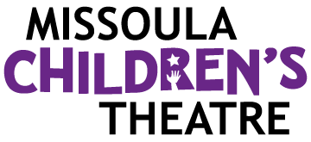  Celebrating over 50 years of touring, the Missoula Children’s Theatre International Tour has fostered developmental life skills in more than a million kids. Our tour reaches 65,000 children in more than 1,000 communities in all 50 states and 15+ countries each year. One of the many ways the Missoula Children’s Theatre remains vibrant is through generous donors all over the world. If you would like to support MCT, visit MCTinc.org/give or text “MCTGive” to 44321.    “Guess what? I made it…I’m in the play!”  On stage or behind the scenes, your child is a STAR! We invite you to honor their experience with a “star” in the MCT Galaxy, located in MCT headquarters in Missoula, MT! To see a sample of a star and learn more about this unique way to celebrate your child and support MCT, visit MCTinc.org/get-involved/mct-galaxy-wall. Stars are only $50 and can be customized with a name, the memory you wish to commemorate, date and location.    Missoula Children’s Theatre  200 N. Adams, Missoula, MT 59802-4718  MCTinc.org 406-728-1911 tour@MCTinc.org |  |  |  | 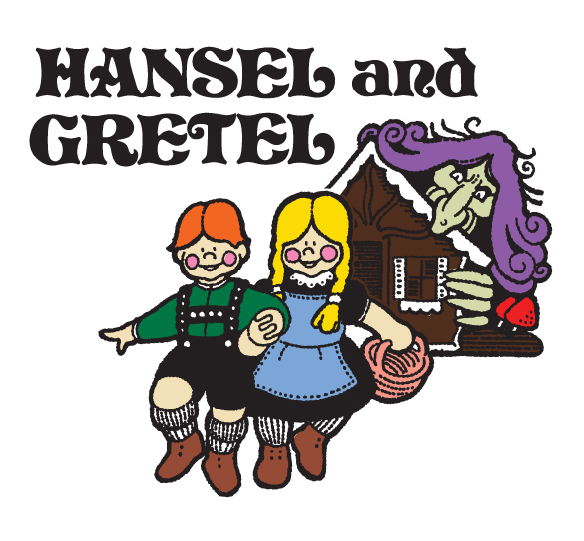  Adapted by  JIM CARON  Music and Lyrics by  MICHAEL MCGILL and JIM CARON  Copyright © 2011 MCT, Inc.  MISSOULA CHILDREN’S THEATRE (MCT, INC)  200 North Adams Missoula, Montana 59802-4718  Phone 406-728-1911 Fax 406-721-0637  www.MCTinc.org  All Rights Reserved
CAST OF CHARACTERS  Hank/Hansel  Gretchen/Gretel  Wildwood Witch  Granny  Cooks  Old Campers  New Campers  Rascals  Wallybirds  Assistant Directors  Accompanist  Aunt/Uncle Wally, Giant Wallybird–Tour Actor/Director  Director–Tour Actor/Director |  |  |  | HANSEL AND GRETEL SYNOPSIS  Times are tough for modern-day Hank and Gretchen, ‘til they find themselves deep in the wondrous Wildwood world of Hansel and Gretel. The Missoula Children's Theatre proudly presents an original musical adaptation of the Brothers’ Grimm age-old tale of a journey, a secret and a grand adventure. Poor Hank and Gretchen! All of their friends, off to summer camp, have left them behind. While waiting for dinner, Hank and Gretchen fall asleep and dream their way to times gone by. They wake with a start! Their clothes are so strange – and so are their names. Lost in the deep dark woods, Granny leads Hansel and Gretel on a search for the path which will lead them to better times at home. But as evening approaches and the moon rises above the trees, Hansel and Gretel are not alone! The Rascals dart from tree to tree as sweet little Wallybirds innocently munch on the cookie crumbs left as a map on the forest floor. Crafty cooks and Gingerbread Men lead our heroes to a colorful cottage concocted completely of candy and cakes, where Hansel and Gretel unravel the secret of the Wildwood Witch: Is she bad? Or is she good? Is she wicked…Or misunderstood? There’s music and laughter and thrills and chills. So join the fun as Hansel and Gretel’s dream is mysteriously blended with real life, and the lessons of one apply to the other. You’ll learn the secret of the Wildwood --- but, shhh --- don’t tell!  TOUR SPONSORS  

