About Program Notes

Programs for performances can disperse valuable and interesting information. They also make terrific souvenirs for the cast.

We require that you include the following:

- The Missoula Children’s Theatre authorship credits for key creative personnel and copyright information found on the next page.

We encourage you to include the following at your discretion, should room permit:

- The included show synopsis and MCT company overview.

- All foundation and/or arts organization graphics included.

- Any local sponsoring organization logo or information.

- Complete list of cast members, assistant directors, accompanist, lighting technician, school staff and anyone else who helped to make your week a success.

Along with the following statements:

- There should be no flash photography during the performance. There will be a time for photos immediately following the show.

- Please observe the following video courtesies: keep the aisles clear and stay in one place while recording.

- Please silence all cell phones.

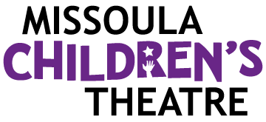  Celebrating over 50 years of touring, the Missoula Children’s Theatre International Tour has fostered developmental life skills in more than a million kids. Our tour reaches 65,000 children in more than 1,000 communities in all 50 states and 15+ countries each year. One of the many ways the Missoula Children’s Theatre remains vibrant is through generous donors all over the world. If you would like to support MCT, visit MCTinc.org/give or text “MCTGive” to 44321.    “Guess what? I made it…I’m in the play!”  On stage or behind the scenes, your child is a STAR! We invite you to honor their experience with a “star” in the MCT Galaxy, located in MCT headquarters in Missoula, MT! To see a sample of a star and learn more about this unique way to celebrate your child and support MCT, visit MCTinc.org/get-involved/mct-galaxy-wall. Stars are only $50 and can be customized with a name, the memory you wish to commemorate, date and location.    Missoula Children’s Theatre  200 N. Adams, Missoula, MT 59802-4718  MCTinc.org 406-728-1911 tour@MCTinc.org |  | 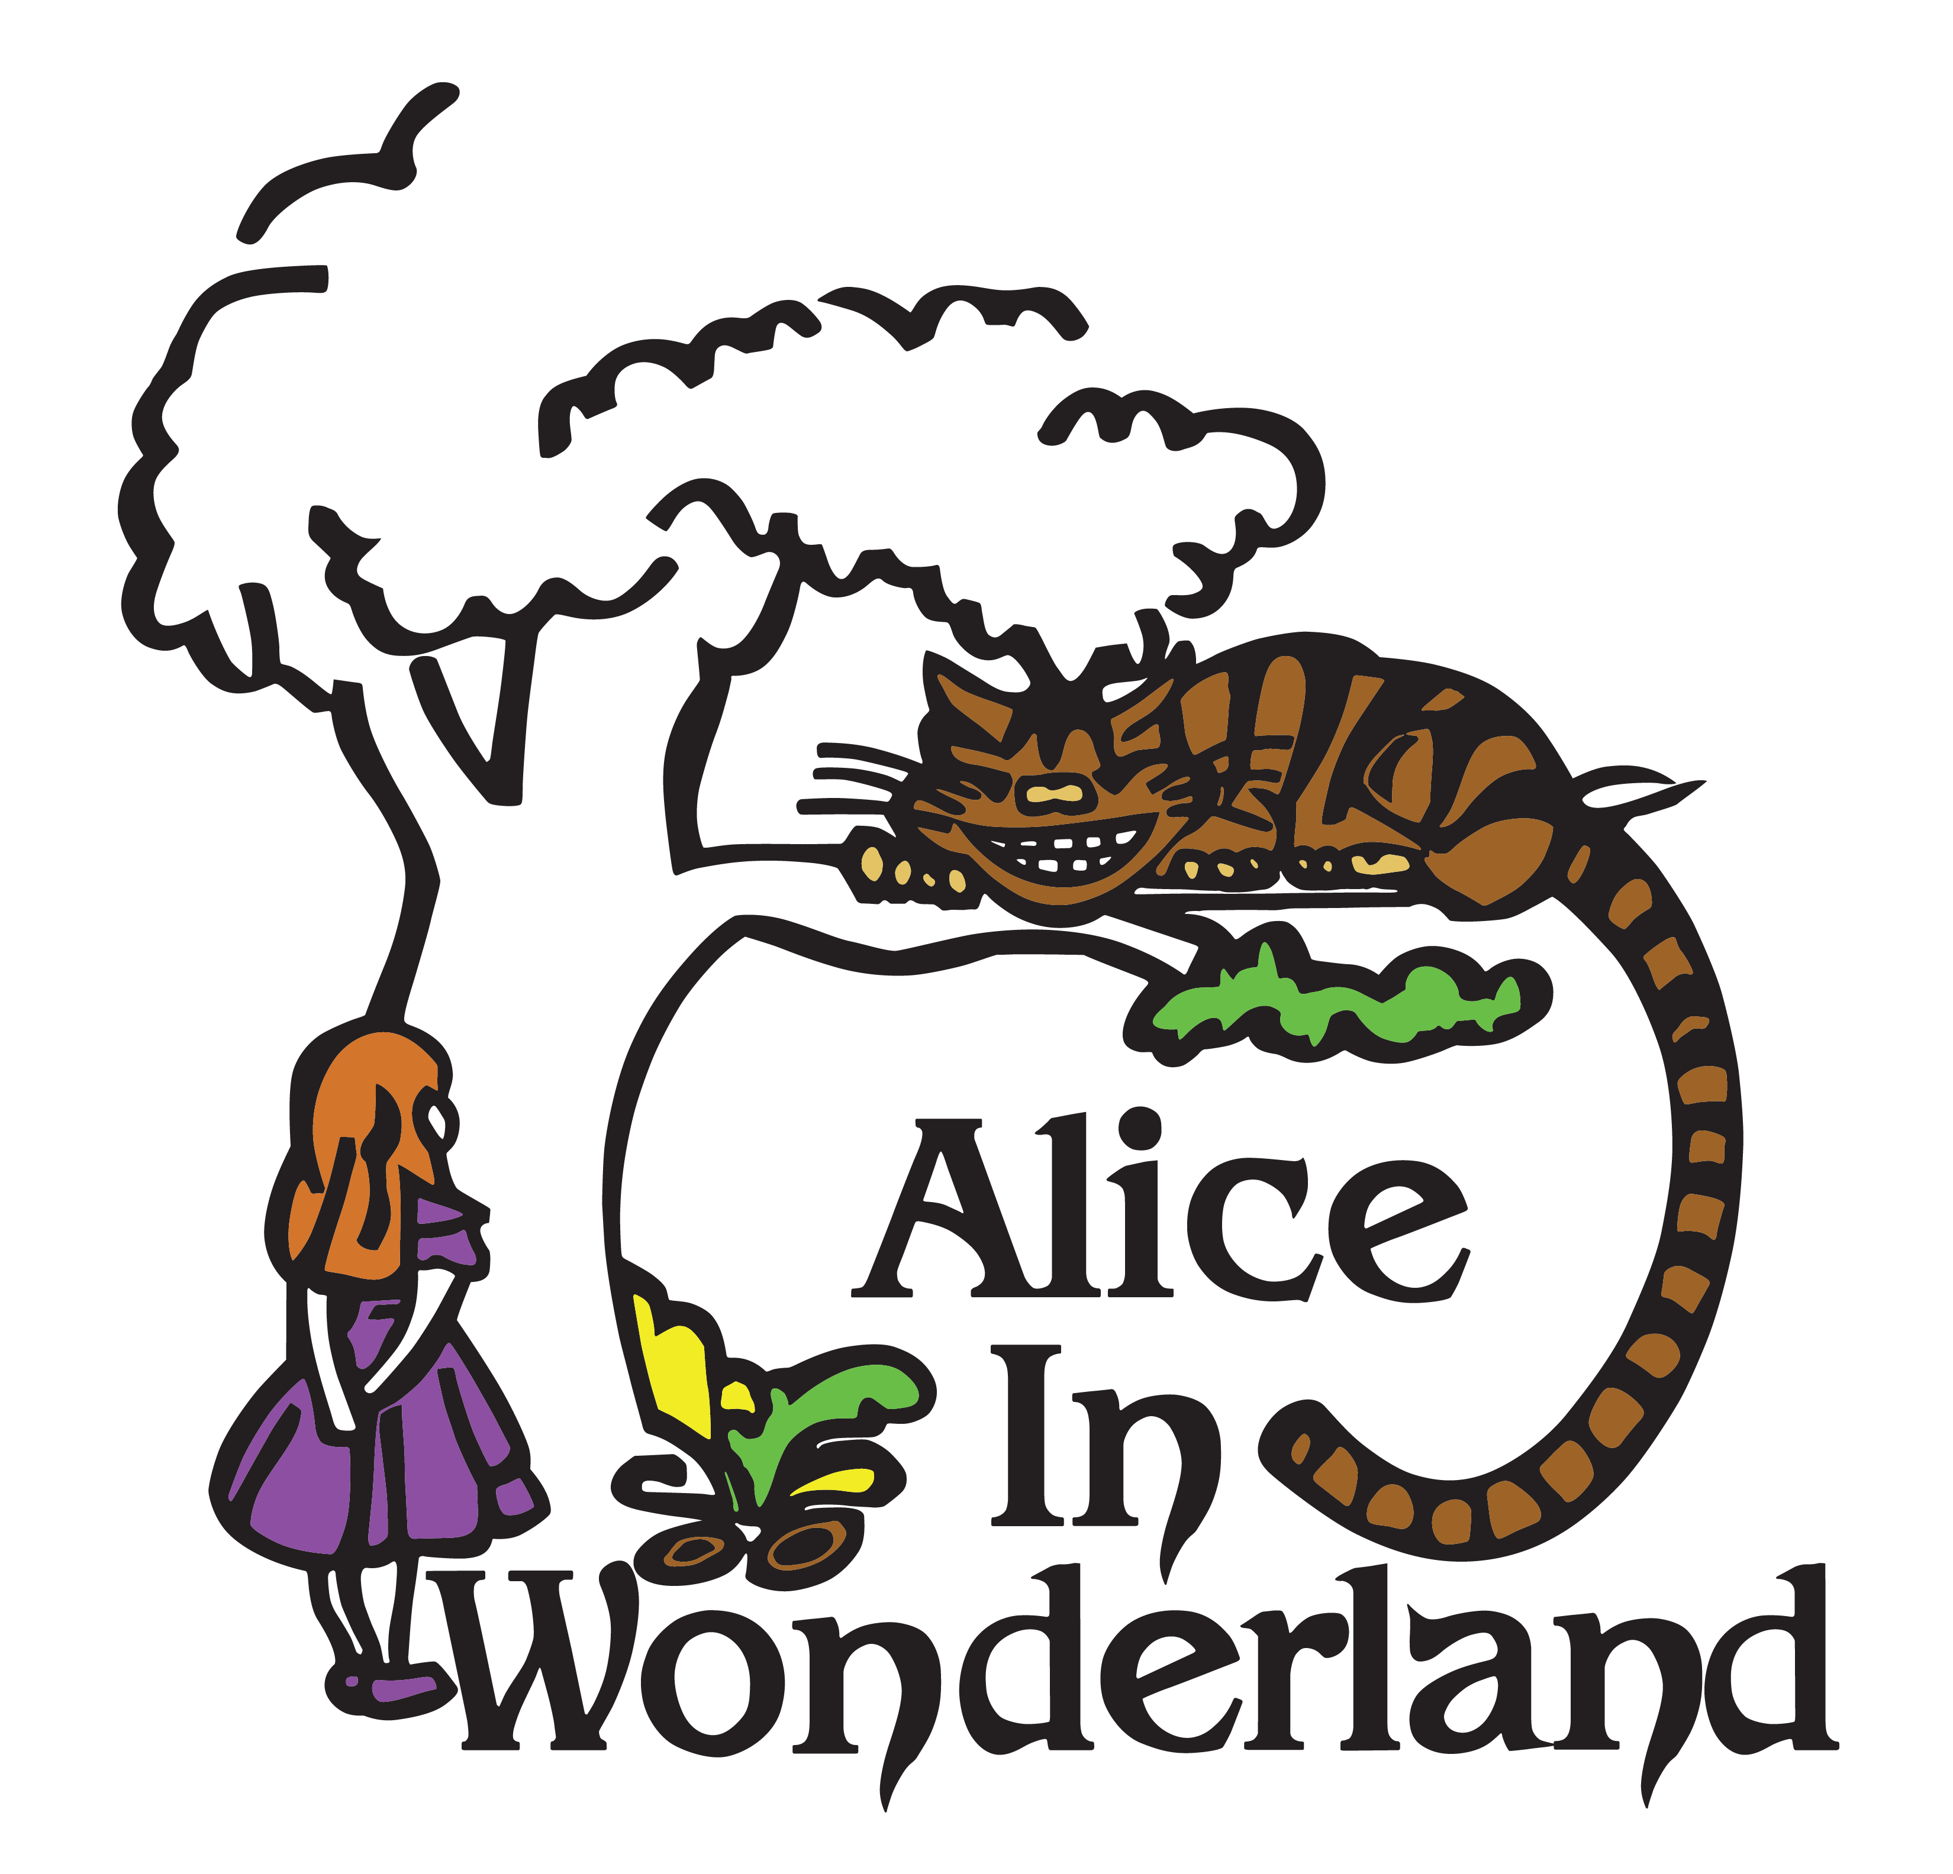  Based upon “Alice’s Adventures in Wonderland” and  “Through the Looking Glass” by Lewis Carroll  Music by  DAVID W. SIMMONS  Lyrics by  LEWIS CARROLL, WILLIAM SHAKESPEARE  and DAVID W. SIMMONS  Staging by  DON KUKLA  Copyright © 2011 MCT, Inc.  MISSOULA CHILDREN’S THEATRE (MCT, INC)  200 North Adams Missoula, Montana 59802-4718  Phone 406-728-1911 Fax 406-721-0637  MCTinc.org  All Rights Reserved
CAST OF CHARACTERS  Tall Alice  Middle Alice  Small Alice  Margaret  King of Hearts  Knave of Hearts  Queen of Hearts  Ace of Hearts  Gryphon  Mock Turtle  March Hare  Mad Hatter  Dormouse  Duchess  Cook  Fish  Frog  Humpty Dumpty  Cheshire Cat 1  Cheshire Cat 2  Cheshire Cat 3  Tweedle Dee  Tweedle Dum  Caterpillar Head  Caterpillar Body  Flowers  Cards  Lobsters  Assistant Directors  Accompanist  White Rabbit–Tour Actor/Director  Director–Tour Actor/Director |  | ALICE IN WONDERLAND SYNOPSIS  The Missoula Children’s Theatre presents ALICE IN WONDERLAND, an original adaptation based on Lewis Carroll’s Alice’s Adventures in Wonderland and Through the Looking Glass. The story begins with Alice and her older sister Margaret reading together. Margaret becomes frustrated, as Alice is curious about absolutely everything. Suddenly, a White Rabbit appears from nowhere. After a quick and nonsensical conversation, Alice follows the rabbit to a strange and wonderful place. In the course of her adventures, Alice meets a band of Flowers, the King and Queen of Hearts, the Knave and the rest of the suit of Cards, a giant Caterpillar, a Fish, a Frog, the Duchess, the Cook, the Cheshire Cat, the Gryphon, the Mock Turtle, a group of singing Lobsters, Tweedle Dee and Tweedle Dum, the March Hare, the Mad Hatter, the Dormouse and Humpty Dumpty. Through it all, Alice grows “curiouser and curiouser” as to where she is and even who she is. In the end, the answers she seeks are unimportant. Wonderland is all nonsense, anyway. As the White Rabbit explains, “Nonsense is fun!”  TOUR SPONSORS  

