About Program Notes

Programs for performances can disperse valuable and interesting information. They also make terrific souvenirs for the cast.

We require that you include the following:

- The Missoula Children’s Theatre authorship credits for key creative personnel and copyright information found on the next page.

We encourage you to include the following at your discretion, should room permit:

- The included show synopsis and MCT company overview.

- All foundation and/or arts organization graphics included.

- Any local sponsoring organization logo or information.

- Complete list of cast members, assistant directors, accompanist, lighting technician, school secretary and anyone else who helped to make your week a success.

Along with the following statements:

- There should be no flash photography during the performance. There will be a time for photos immediately following the show.

- Please observe the following video courtesies: keep the aisles clear and stay in one place while recording.

- Please silence all cell phones.

  Celebrating over 50 years of touring, the Missoula Children’s Theatre International Tour has fostered developmental life skills in more than a million kids. Our tour reaches 65,000 children in more than 1,000 communities in all 50 states and 15+ countries each year. One of the many ways the Missoula Children’s Theatre remains vibrant is through generous donors all over the world. If you would like to support MCT, visit MCTinc.org/give or text “MCTGive” to 44321.    “Guess what? I made it…I’m in the play!”  On stage or behind the scenes, your child is a STAR! We invite you to honor their experience with a “star” in the MCT Galaxy, located in MCT headquarters in Missoula, MT! To see a sample of a star and learn more about this unique way to celebrate your child and support MCT, visit MCTinc.org/get-involved/mct-galaxy-wall. Stars are only $50 and can be customized with a name, the memory you wish to commemorate, date and location.    Missoula Children’s Theatre  200 N. Adams, Missoula, MT 59802-4718  MCTinc.org 406-728-1911 tour@MCTinc.org |  | 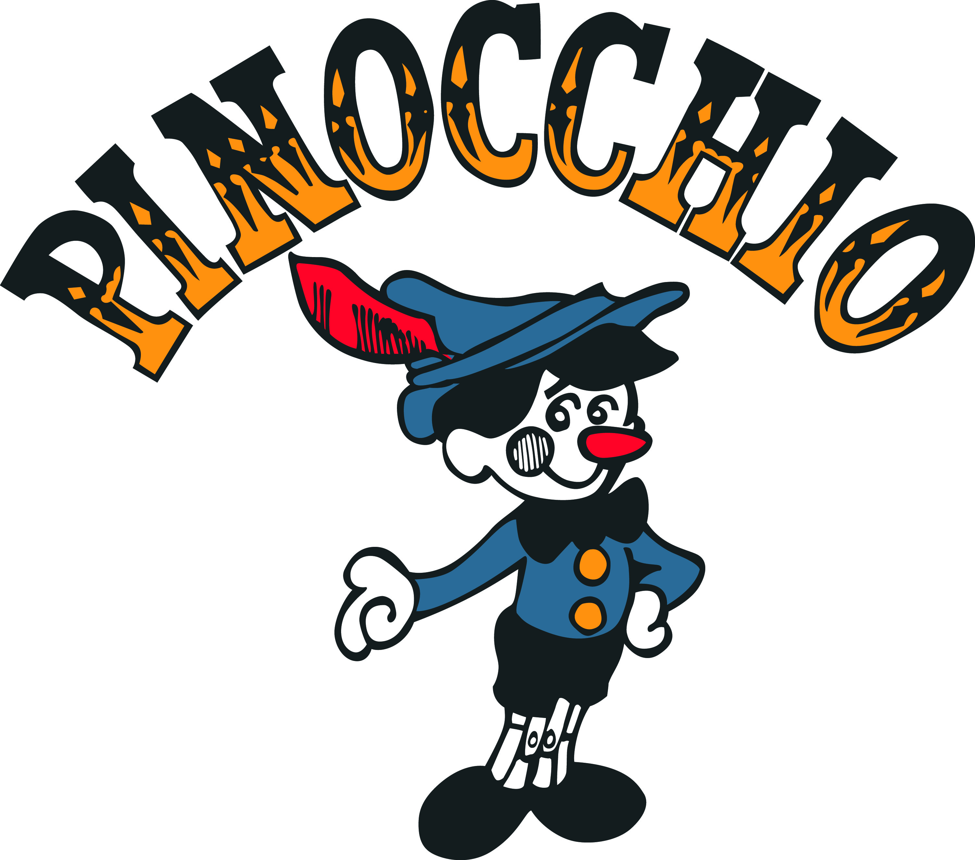  Adapted by  JIM CARON  Music and Lyrics by  MICHAEL MCGILL and JIM CARON  Additional Music by  DON COLLINS and CAROL WEBBER  Copyright © 2011 MCT, Inc.  MISSOULA CHILDREN’S THEATRE (MCT, INC)  200 North Adams Missoula, Montana 59802-4718  Phone 406-728-1911 Fax 406-721-0637  MCTinc.org  All Rights Reserved
CAST OF CHARACTERS  Pinocchio  Jiminy Cricket  Blue Fairy  Fox  Cat  Candlewick  Candlewick’s Crew  Urchins  Harlequin  Columbine  Scaramouche  School Kids  Toys  Assistant Directors  Accompanist  Geppetto/Stromboli–Tour Actor/Director  Director–Tour Actor/Director |  | PINOCCHIO SYNOPSIS  Geppetto fashioned the puppet in the image of a small boy. Even as the lonely and kind woodcarver worked far into the night, old Geppetto was not aware that the wood under the chisel had come from the trunk of an enchanted tree. But the Blue Fairy was aware, as she watched from afar and gave to that puppet the gift of life. Thus begins the Missoula Children's Theatre adaptation of one of the most beloved of all children’s stories–PINOCCHIO. Join our wooden-head as he dances with Geppetto’s charming toys, travels the road to Pleasure Isle with Candlewick and his Crew, and is swindled by the unsavory Fox and Cat. After escaping the clutches of the evil puppetmaster, Stromboli, Pinocchio finds himself in trouble once more–this time swallowed by a monstrous whale. Very scary stuff! As Geppetto and the friendly Urchins spin their magical tale, we learn with Pinocchio that there are no shortcuts on the road to becoming a real, live boy.  TOUR SPONSORS  

